**AWS Task-4**

**Task Description:**

Launch an EC2 instance (Linux and Windows) along with a web server. Then, create an EBS volume of 5 GB, attach it to an EC2 machine (Linux and Windows), and take a snapshot. Finally, create an EBS volume using the taken snapshot.

Explanation:

1. Login to AWS console and Launch an EC2 instance.

**Linux :**

Name : Linux_instance

AMI : Amazon linux

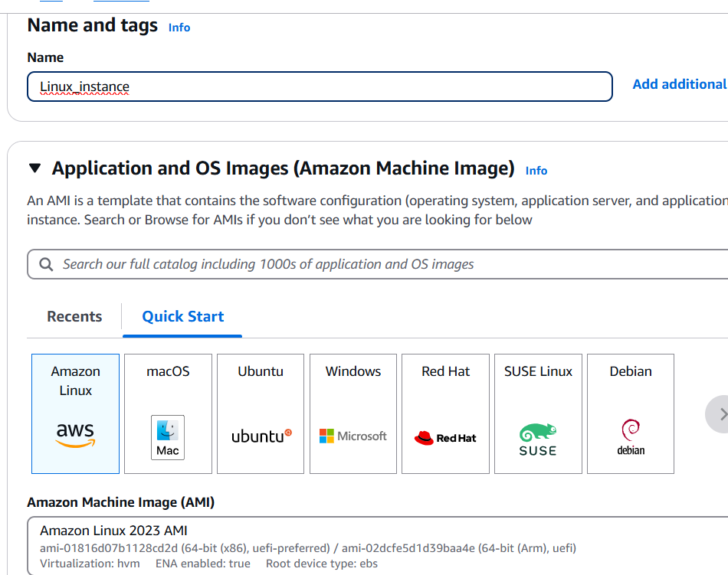

Instance type – t2.micro

Key pair- create or choose existing one

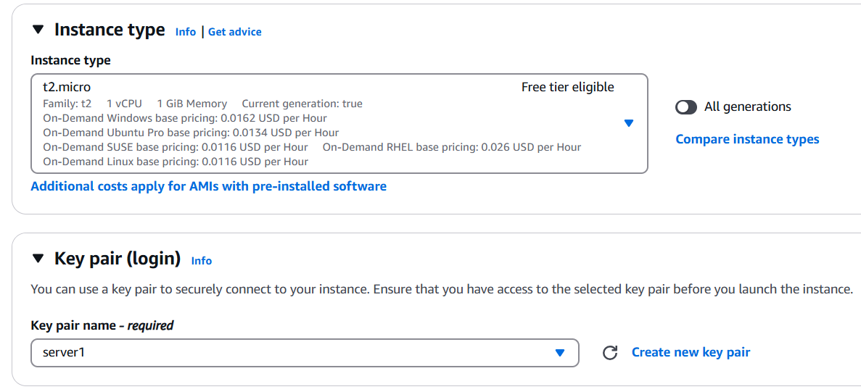

Under security group allow ssh port.



Launch instance.

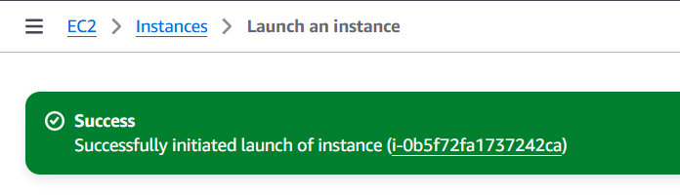

1. **Windows Instance**:

Name : windows_instance

AMI : Windows

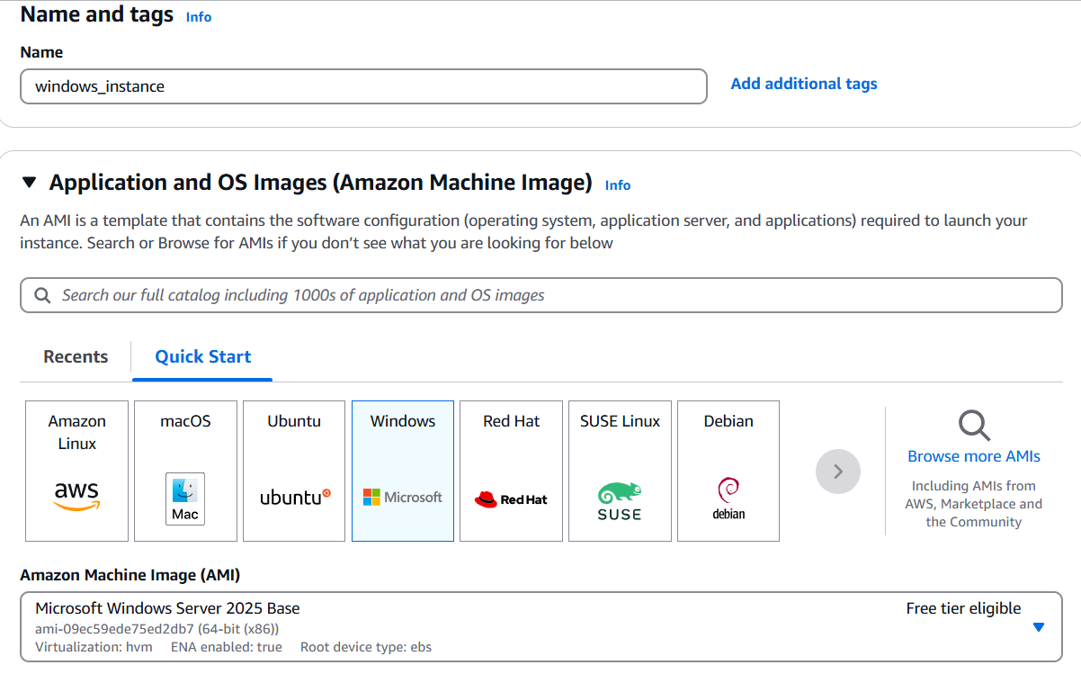

Instance type – t3.micro

Key pair- create or choose existing one

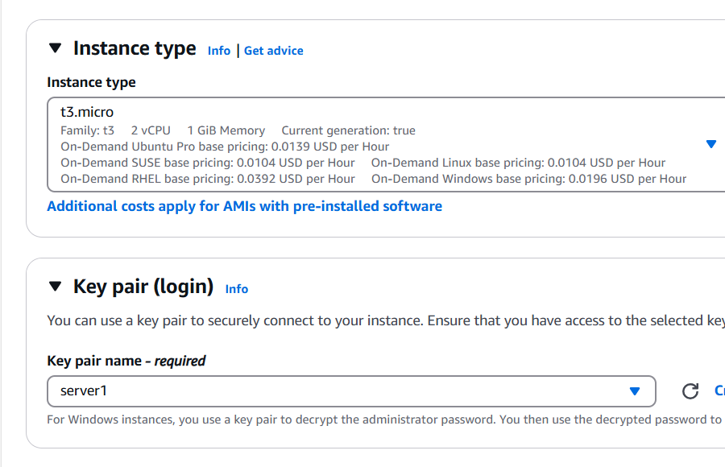

Under security group allow RDP port.

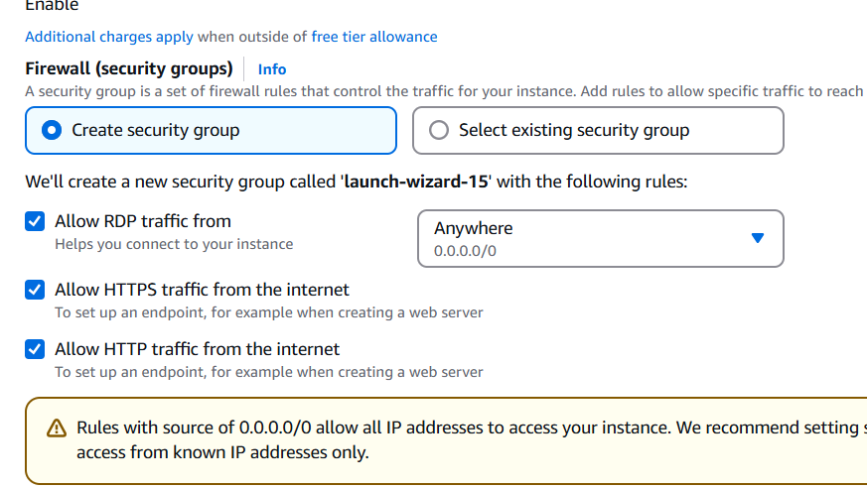

Then Launch instance.

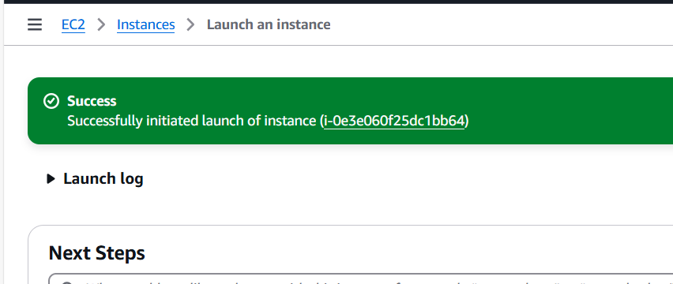

1. Web server

**Linux :**

Connect to linux ec2 instance via ec2 instance connect.

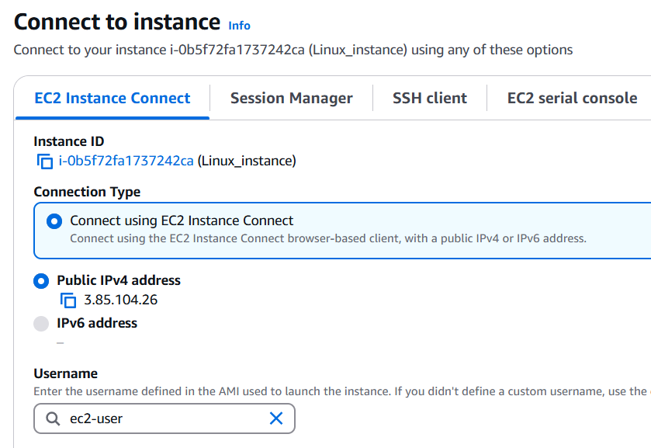

Use the following commands to update packages.

sudo yum update -y

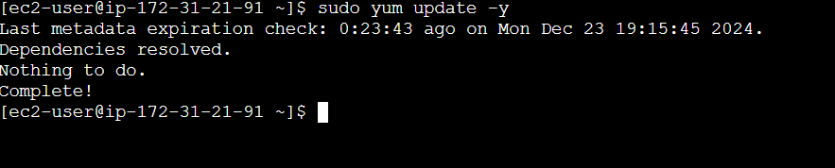

sudo yum install httpd -y

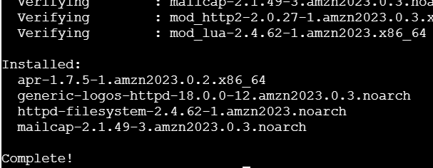

sudo systemctl start httpd

sudo systemctl enable httpd



To print the desired message

echo "Welcome to Linux Web Server" | sudo tee /var/www/html/index.html



1. **Windows** :

Connect the windows using RDP Client. Click get password by uploading the pem file. Copy the password - 2t1k?5g0M6yJKOtZw9vI(i4eHg?oHQA1

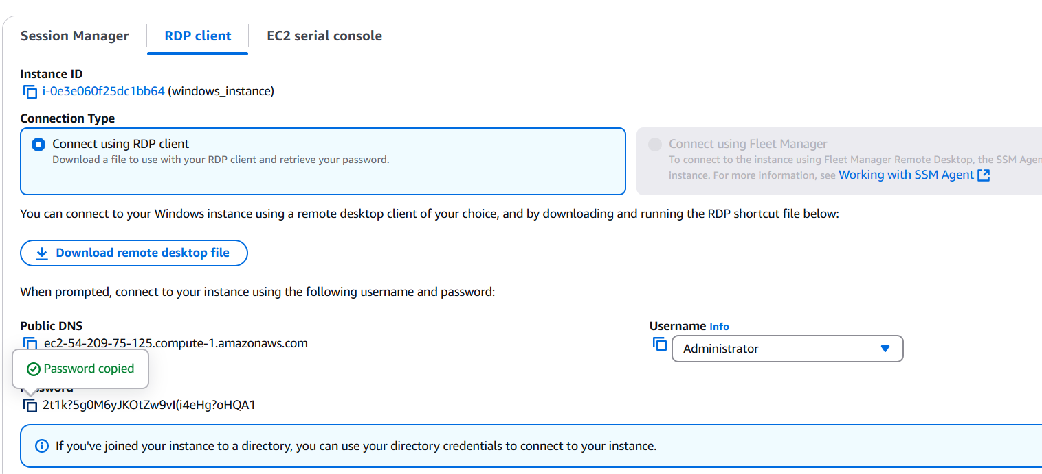

To connect via RDP, use mstsc

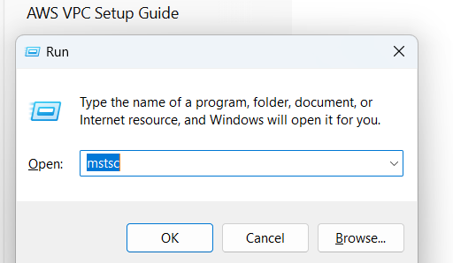

Use the copied password to launch RDP connection.

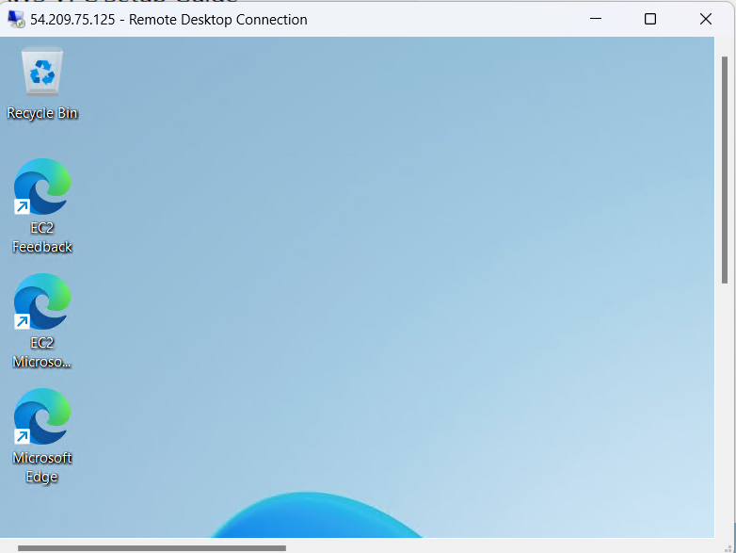

Once launched, open server manager from start menu.

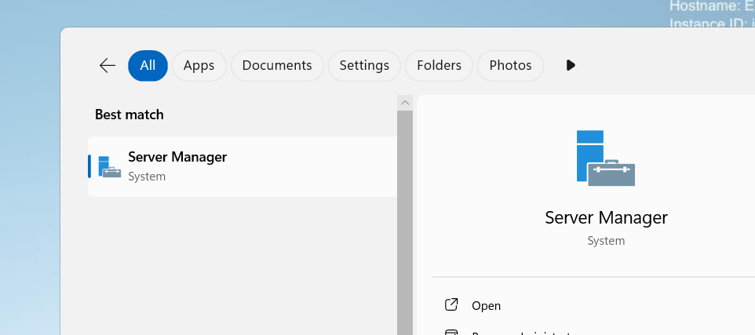

Click add roles and features

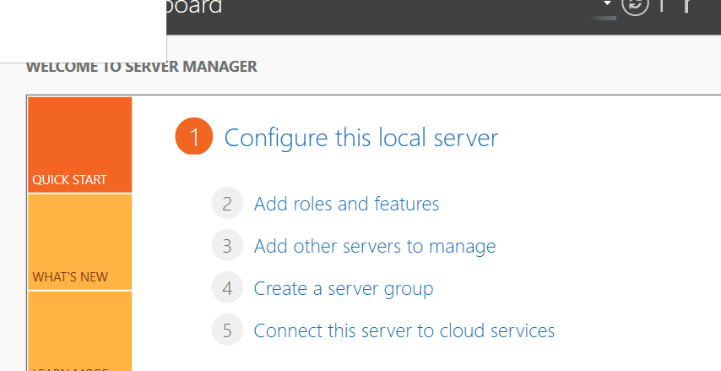

Select webserver under the roles and install the feature.

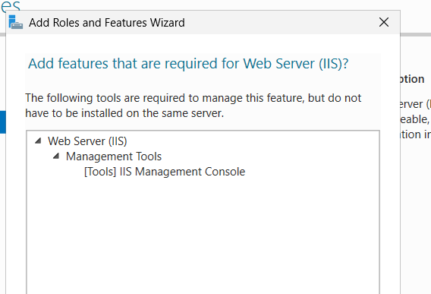

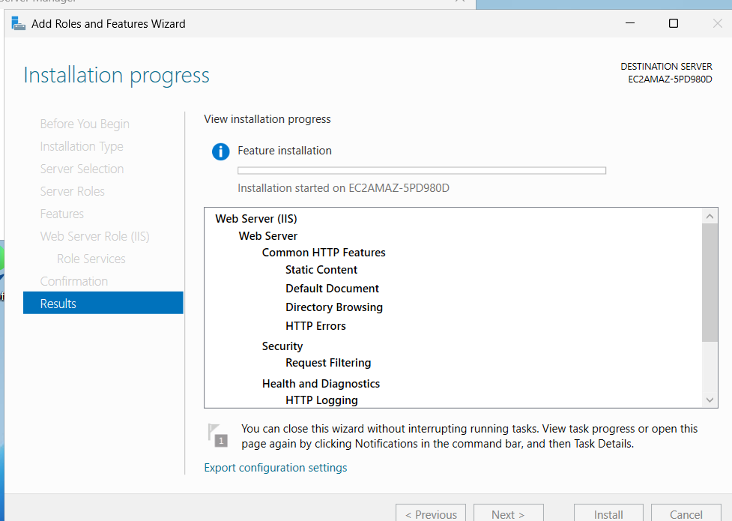

Nacigate to inetpub

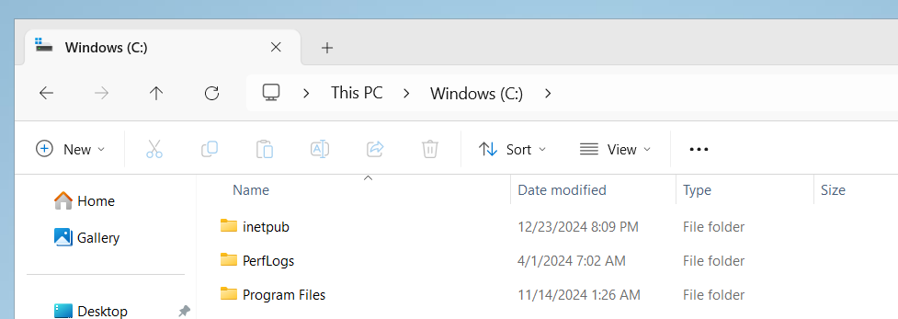

Choose wwwroot

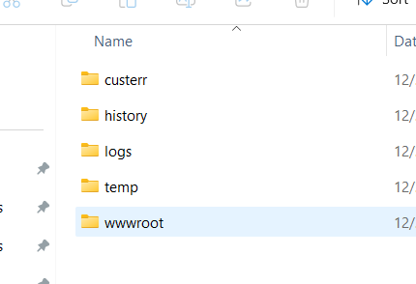

Create new html file in the wwwroot folder, name it as index.html.

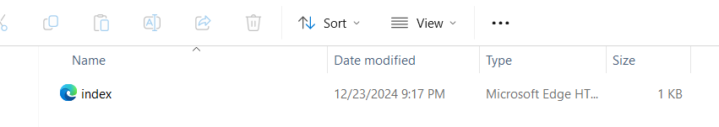

Paste the following content.

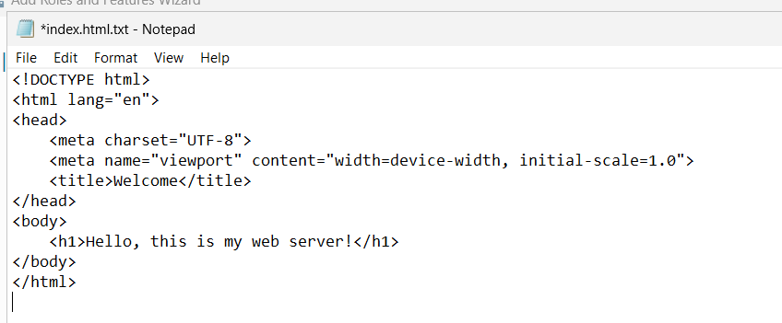

Verify by the public v4 address whether the given message via html file is displayed.

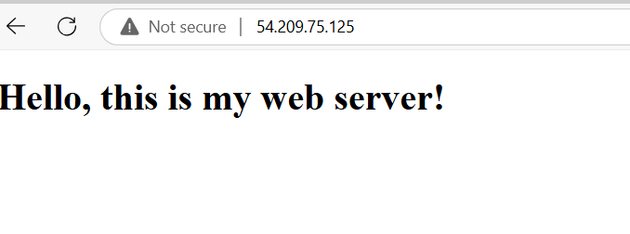

1. Create the EBS Volume

Navigate to EC2 dashboard > Elastic Block Store>Volumes > Create Volume

Set size 5 GB and choose the availability zone same as the ec2 instance.

**Linux :**

To attach the created ebs volume, select the created volume, navigate to actions>attach volume> select the linux instance (due to availability zone, for windows another volume is created with same availability zone)

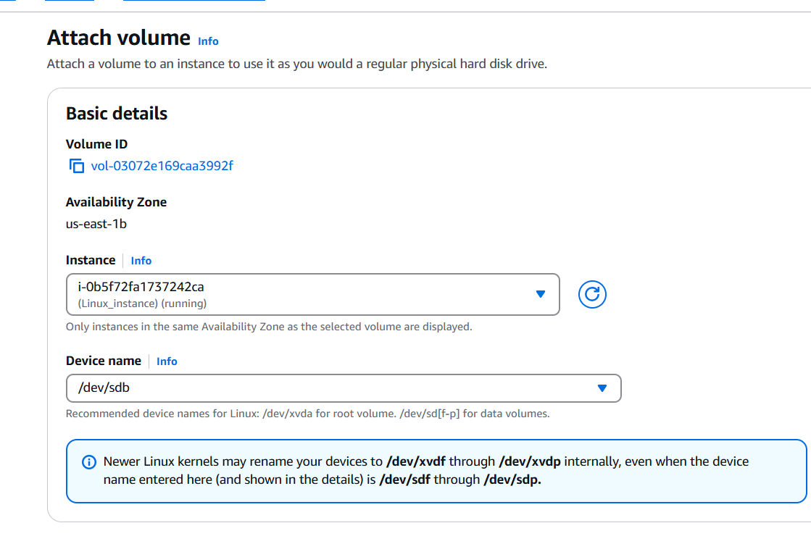

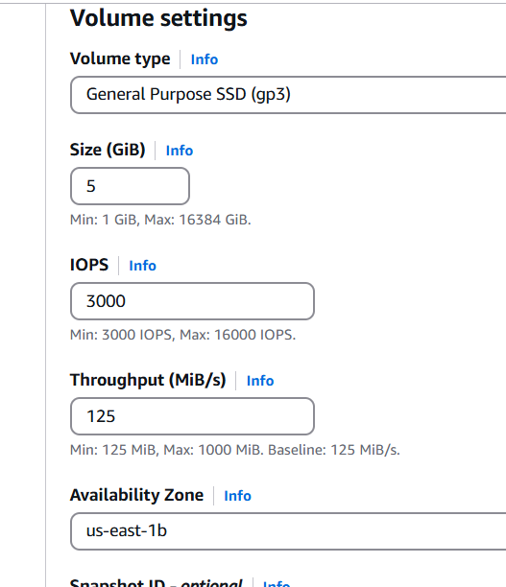

Connect to the EC2 instance

Use the following commands

Lsblk

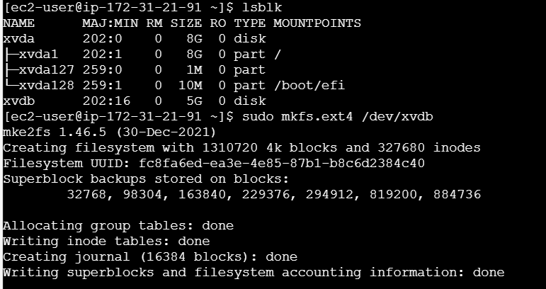

sudo mkfs.ext4 /dev/xvdb – format the volume

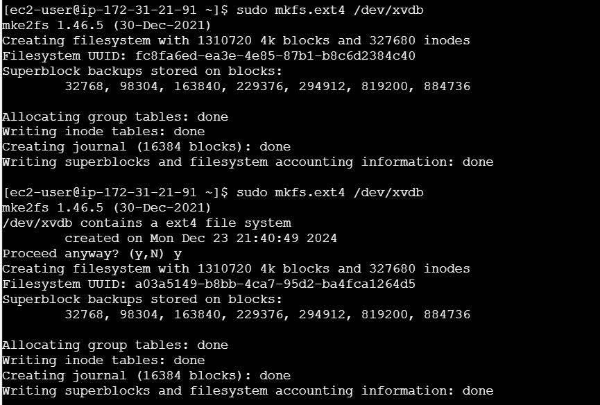

Mount the volume - sudo mkdir /mnt/data

sudo mount /dev/xvdb /mnt/data

echo '/dev/xvdb /mnt/data ext4 defaults 0 0' | sudo tee -a /etc/fstab

/dev/xvdb /mnt/data ext4 defaults 0 0



1. For **Windows,**

Repeat the same steps and attach the volume to windows instance.

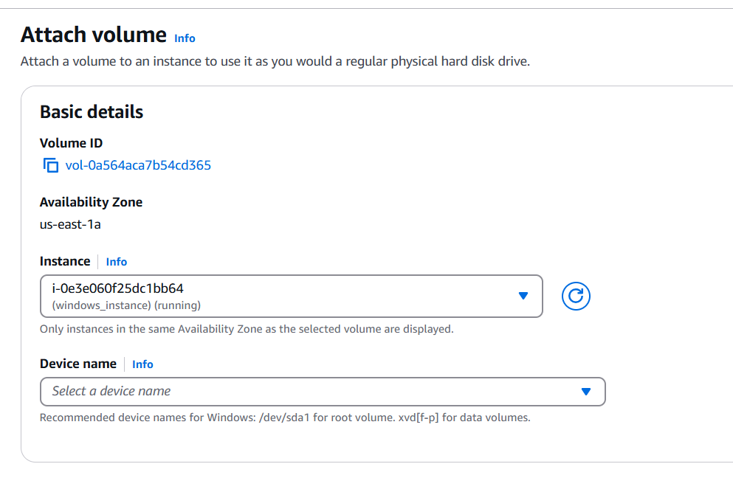

Open disk management in RDP and Locate the attached volume, initialize it, and format it as **NTFS**

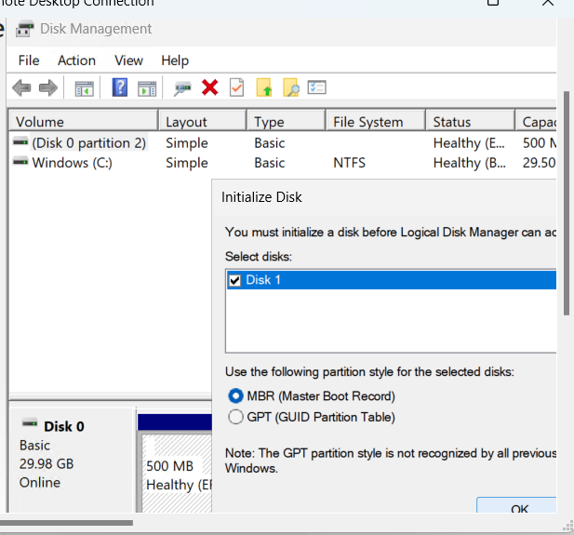

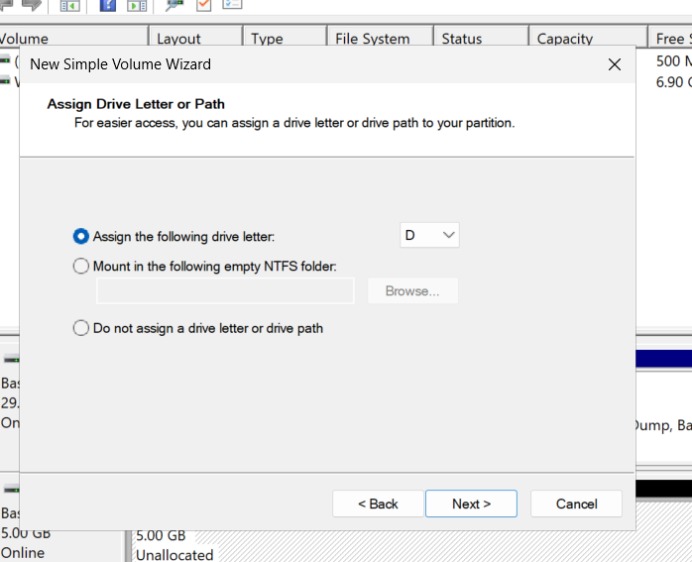

1. Create snapshot

Go to Volumes, select the volume attached to the EC2 instance.

Click Actions > Create Snapshot.

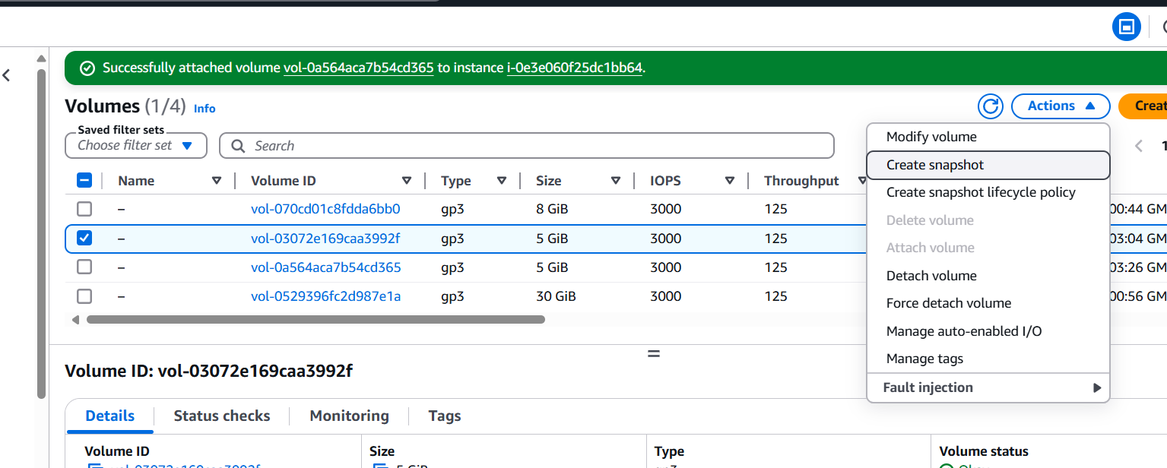

Provide a name and description for the snapshot.

Click Create Snapshot.

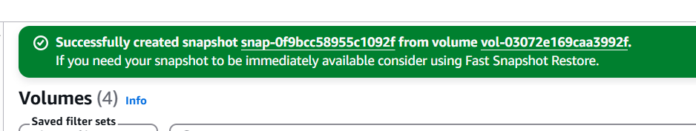

1. Create EBS volume from snapshot

Navigate to Snapshots.

Select the snapshot you just created.

Click Actions > Create Volume.

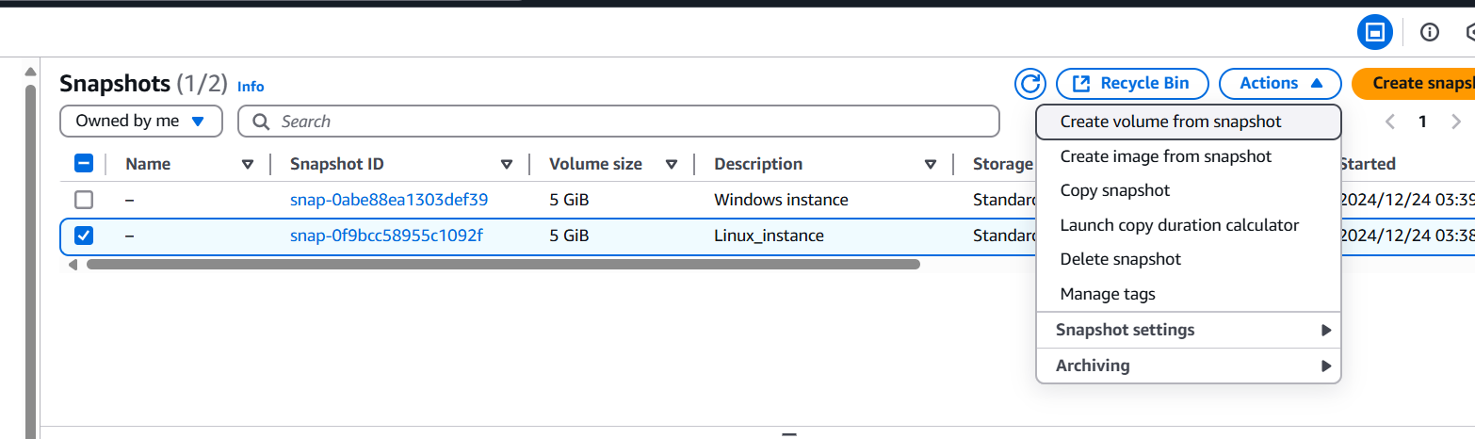

Set the desired size and Availability Zone to match your EC2 instances.

Click Create Volume.

For Linux

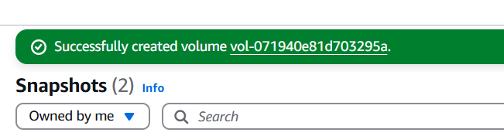

For windows

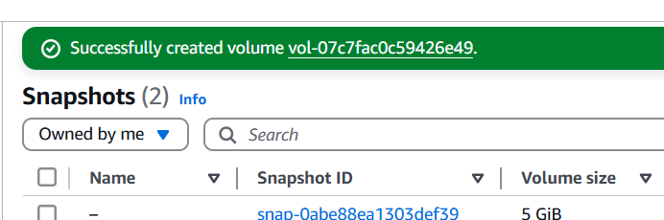

1. Attach the newly created volumes to instances.

Linux:

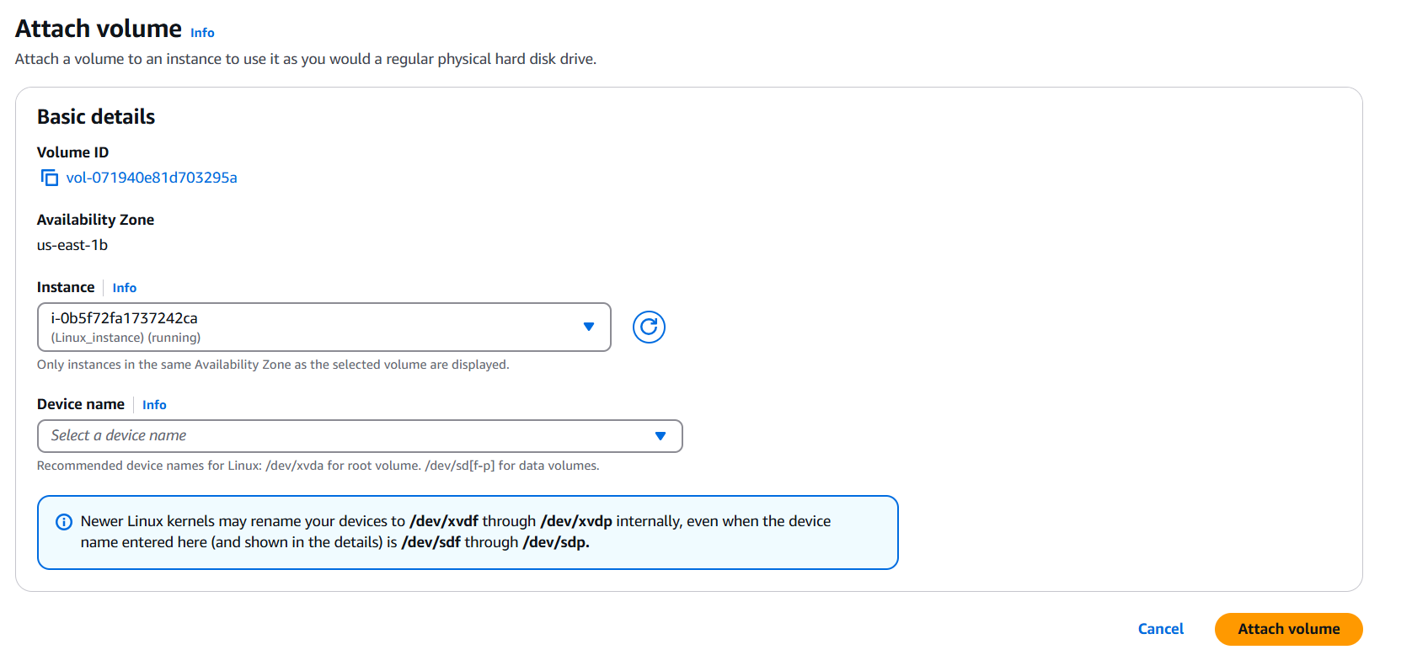

Windows:

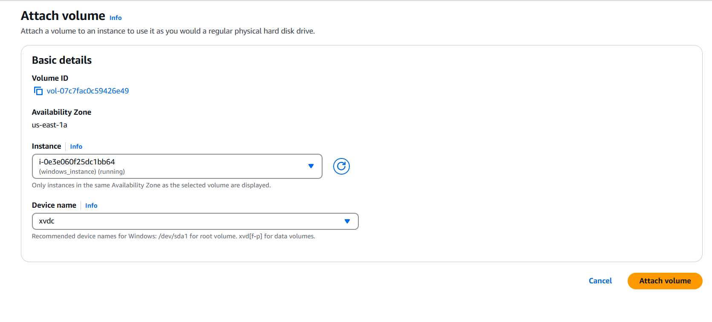

Linux :

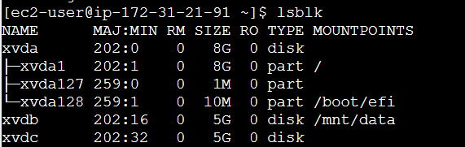

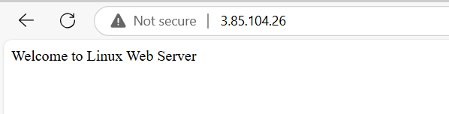

Windows:

